---------------------------------------------------------------------

-- LAB 06

--

-- Exercise 1

---------------------------------------------------------------------

USE TSQL;

GO

---------------------------------------------------------------------

-- Task 1

--

--

-- Write a SELECT statement to return columns that contain:

--1- The current date and time. Use the alias currentdatetime.

--2- Just the current date. Use the alias currentdate.

--3- Just the current time. Use the alias currenttime.

--4- Just the current year. Use the alias currentyear.

--4- Just the current month number. Use the alias currentmonth.

--5- Just the current day of month number. Use the alias currentday.

--6- Just the current week number in the year. Use the alias currentweeknumber.

-- The name of the current month based on the currentdatetime column. Use the alias currentmonthname.

--

-- Execute the written statement and compare the results that you got with the desired results shown in the file 52 - Lab Exercise 1 - Task 1 Result.txt. Your results will be different because of the current date and time value.

--

-- Can you use the alias currentdatetime as the source in the second column calculation (currentdate)? Please explain.

---------------------------------------------------------------------

---------------------------------------------------------------------

-- Detyra 1

--

--

-- Selektoni kolonat qe permbajne:

--1- Daten dhe kohen aktuale. Perdorni alias currentdatetime.

--2- Vetem daten aktuale. Perdorni alias currentdate.

--3- Vetem kohen aktuale. Perdorni alias currenttime.

--4- Vetem vitin aktual. Perdorni alias currentyear.

--5- Vetem numrin e muajt aktual. Perdorni alias currentmonth.

--6- Vetem diten aktuale te muajt. Perdorni alias currentday.

--7- Vetëm numri aktual i javës në vit. Perdorni alias currentweeknumber.

--8- Emri i muajit aktual bazuar në kolonen currentdatetime. Perdorni alias currentmonthname.

--

-- Ekzekutoni query dhe krahasojeni me rezultatin ne file 52 - Lab Exercise 1 - Task 1 Result.txt. Resultati i juaj do te jete i ndryshem per shkak te dates dhe ores aktuale.

--

--9-- Mund ta përdorni alias currentdatetime si burim në llogaritjen e kolonës së dytë (currentdate)? Ju lutem shpjegoni.

---------------------------------------------------------------------

Select currentdatetime = (convert(datetime,GETDATE())),currentdate = cast(GETDATE() AS DATE),currenttime = cast(GETDATE() AS TIME),

currentyear = DATEPART(year,GETDATE()) ,currentmonth = DATEPART(month,GETDATE()),currentday = DATEPART(day,GETDATE()),

currentweeknumber = DATEPART(WEEK,GETDATE()),currentmonthname = DATENAME(month,GETDATE())

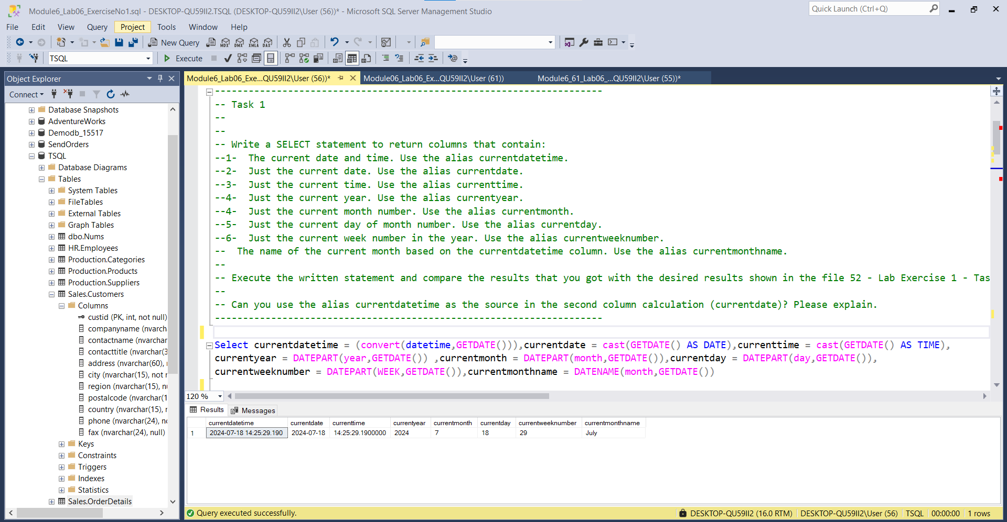

--9-

DECLARE @orderdate DATETIME = (convert(datetime,GETDATE()))

Select currentdate = cast(@orderdate AS date)

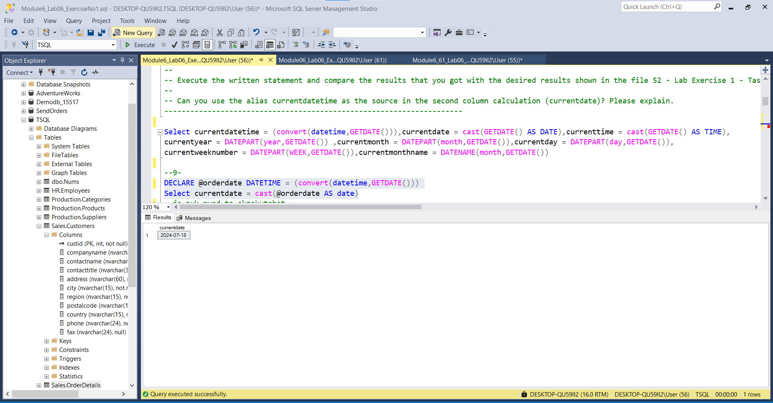

9--jo nuk mund te ekzekutohet

DECLARE @orderdate DATETIME = currentdatetime

Select currentdate = cast(@orderdate AS date) ---------------------------------------------------------------------

-- Task 2

--

-- Write December 11, 2015, as a column with a data type of date. Use the different possibilities inside the T-SQL language (cast, convert, specific function, etc.) and use the alias somedate.

---------------------------------------------------------------------

---------------------------------------------------------------------

-- Detyra 2

--

--1-- Shkruani December 11, 2015, si një kolonë me tipin e te dhenave date.

--2-- Përdorni mundësitë e ndryshme brenda gjuhës T-SQL (cast, convert, specific function, etc, dhe përdorni alias somedate.

---------------------------------------------------------------------

--1--

Select cast('2015-December-11' AS DATE) AS somedate

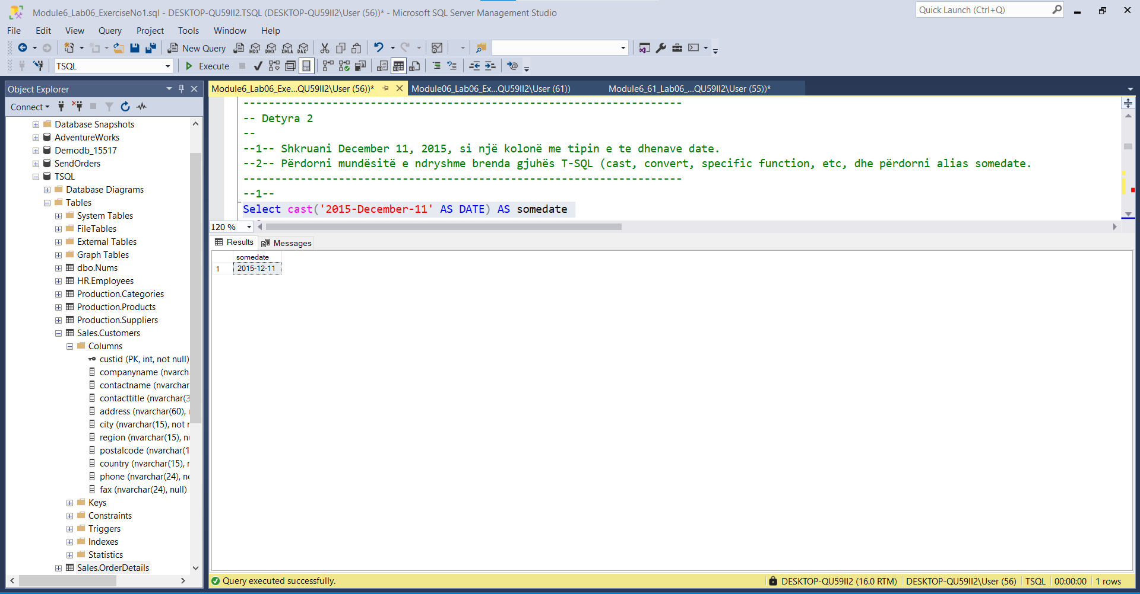

--2--

Select convert(Date,'2015-12-11') as somedate

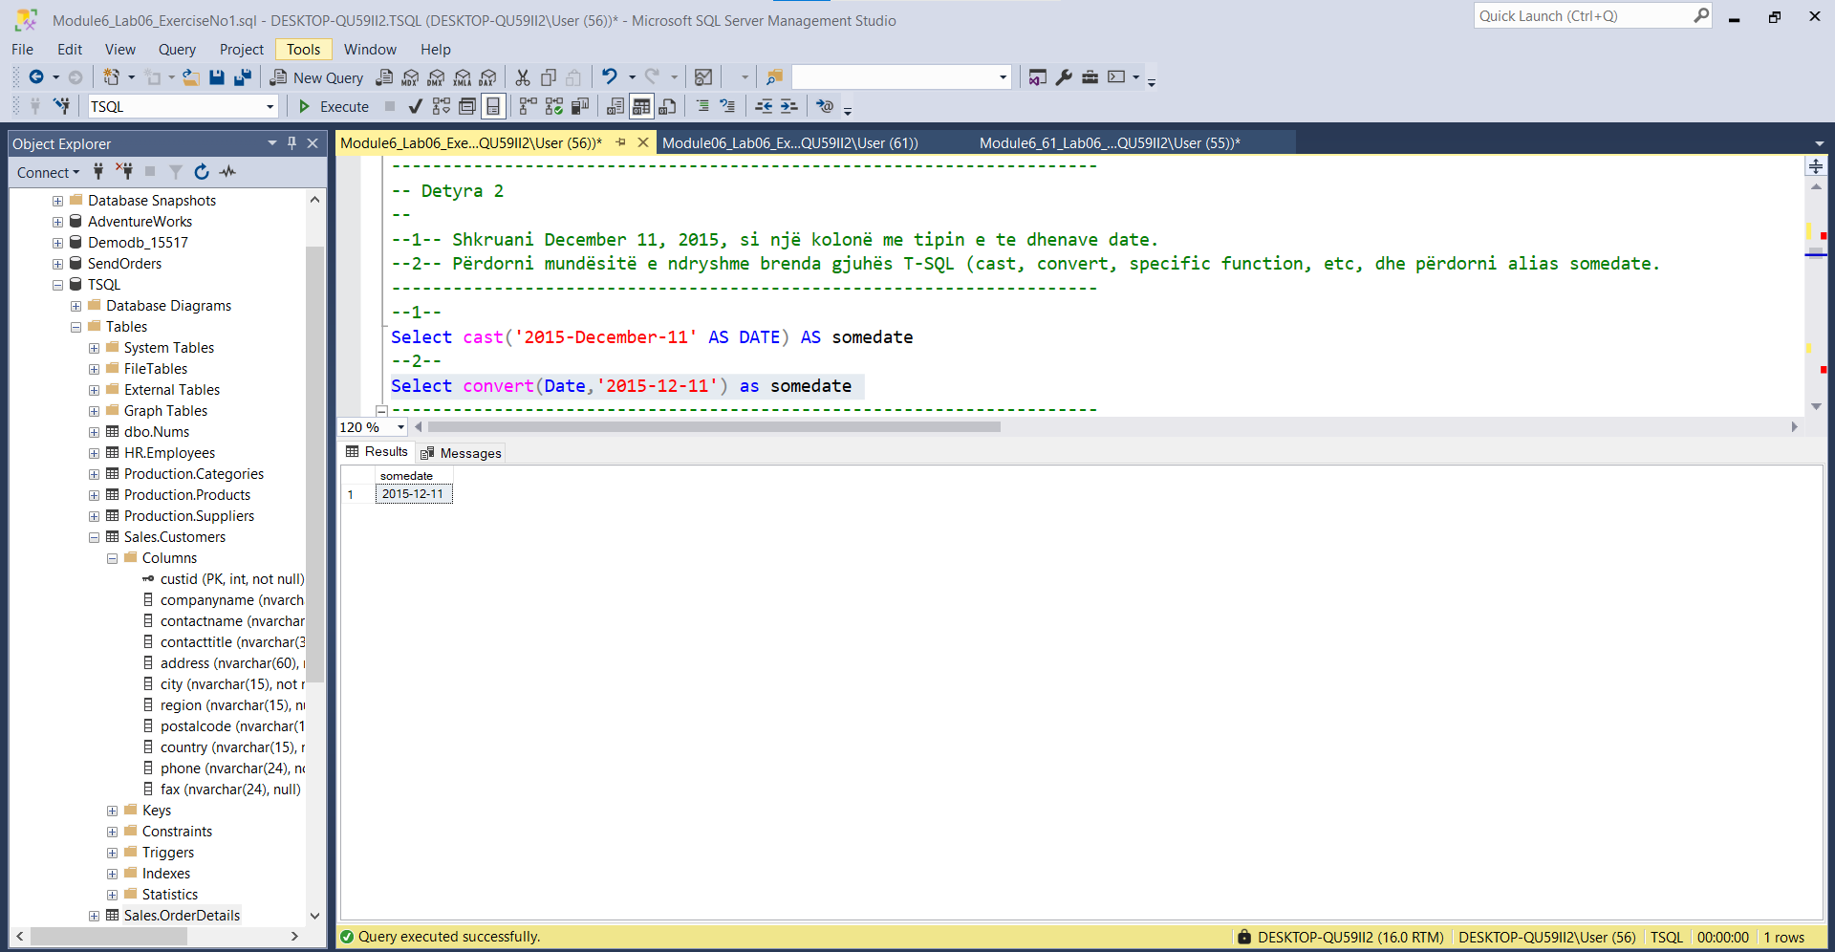

---------------------------------------------------------------------

-- Task 3

--

-- Write a SELECT statement to return columns that contain:

-- Three months from the current date and time. Use the alias threemonths.

-- Number of days between the current date and the first column (threemonths). Use the alias diffdays.

-- Number of weeks between April 4, 1992, and September 16, 2011. Use the alias diffweeks.

-- First day in the current month based on the current date and time. Use the alias firstday.

--

-- Execute the written statement and compare the results that you got with the desired results shown in the file 53 - Lab Exercise 1 - Task 3 Result.txt. Some results will be different because of the current date and time value.

-----------------------------------------------------------------------------------------

-- Detyra 3

--

-- Selektoni kolonat qe permbajne:

--1-- Tre muaj nga data dhe ora aktuale. Perdorni alias threemonths.

--2-- Numrin e diteve midis dates aktuale dhe kolones (threemonths). Perdorni alias diffdays.

--3-- Numrin e javeve midis April 4, 1992, dhe September 16, 2011. Perdorni aliass diffweeks.

--4-- Diten e pare te muajit aktual bazuar ne daten dhe oren aktuale. Perdorni alias firstday.

--

-- Ekzekutoni query dhe krahasojeni me rezultatet ne file 53 - Lab Exercise 1 - Task 3 Result.txt. Disa rezualate do te jene te ndryshme per shkak te dates dhe ores aktuale.

---------------------------------------------------------------------

--1--

Select threemonths = EOMONTH(GETDATE(),3)

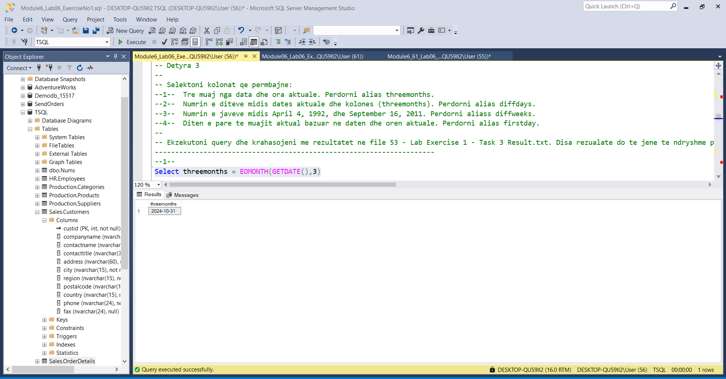

--

DECLARE @D1 DATETIME2 = GETDATE()

SELECT THREEMONTHS = DATEADD(MONTH,3,@D1)

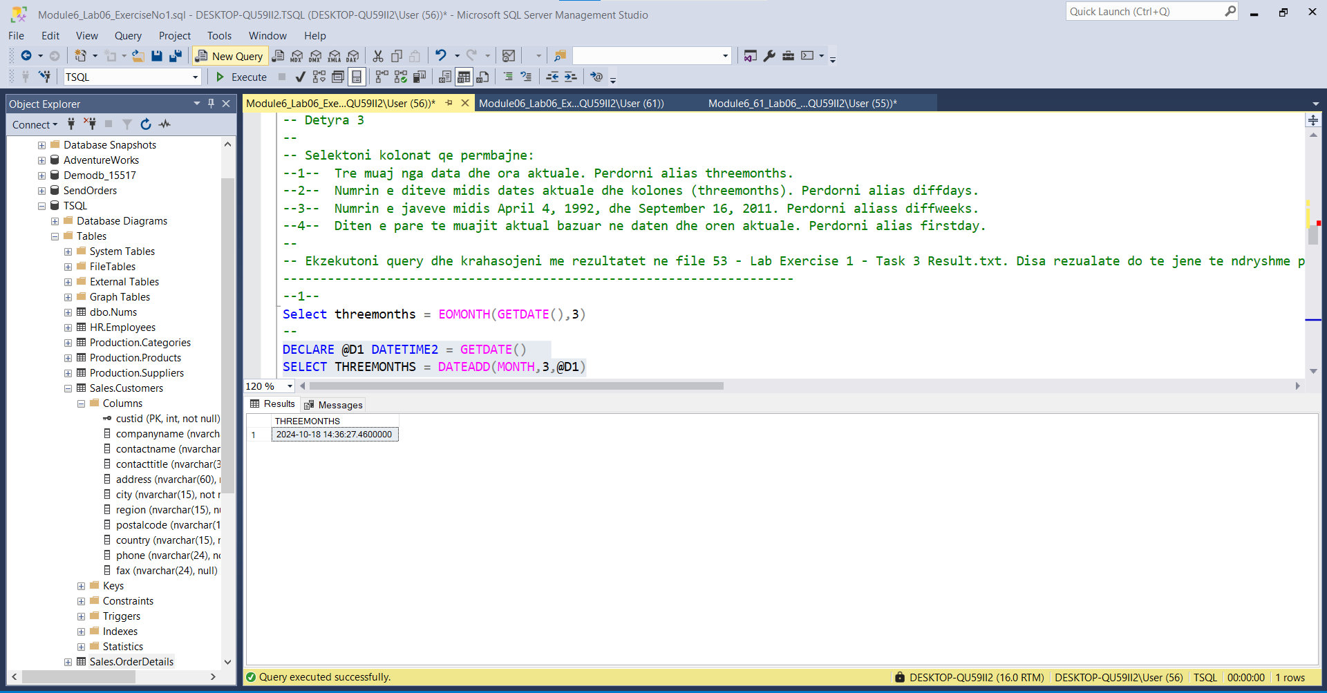

--2--

select DATEDIFF(day,GETDATE(),DATEADD(MONTH,3,GETDATE())) AS diffdays

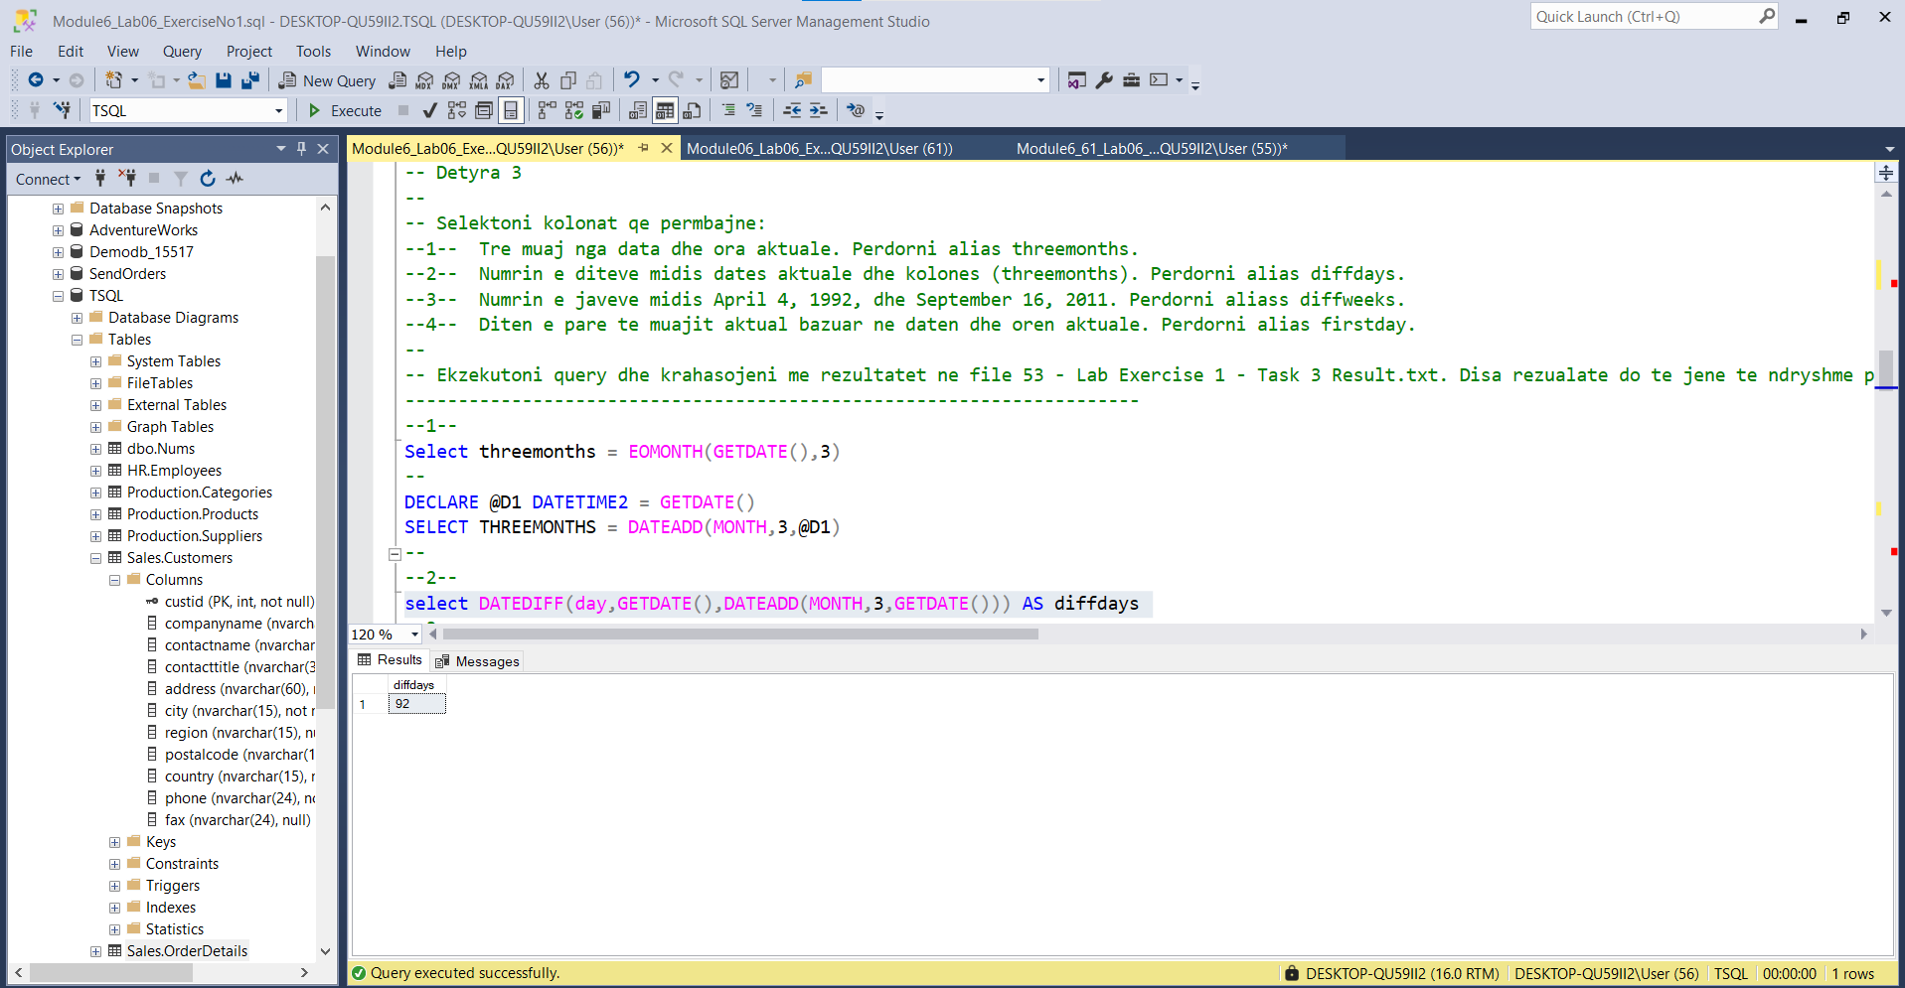

--3--

select DATEDIFF(week,(convert(DATE,'1992-April-04')),(cast('2011-September-16' AS DATE))) as diffweeks

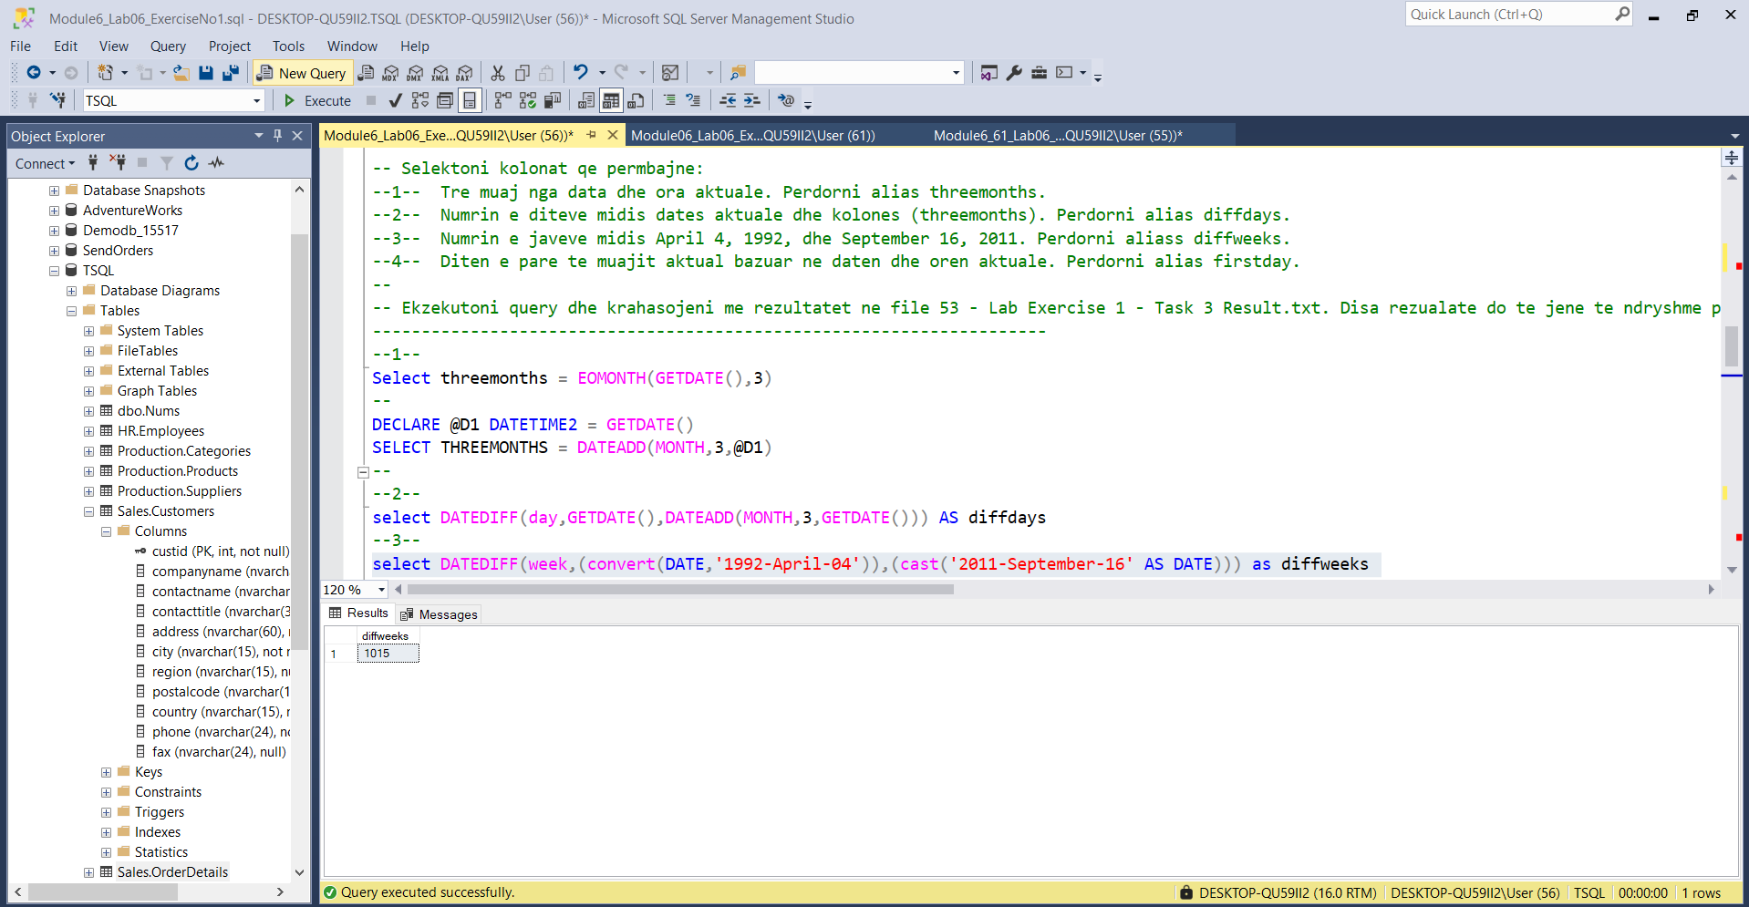

--4--

SELECT firstday = DATEFROMPARTS(YEAR(GETDATE()),MONTH(GETDATE()),1)

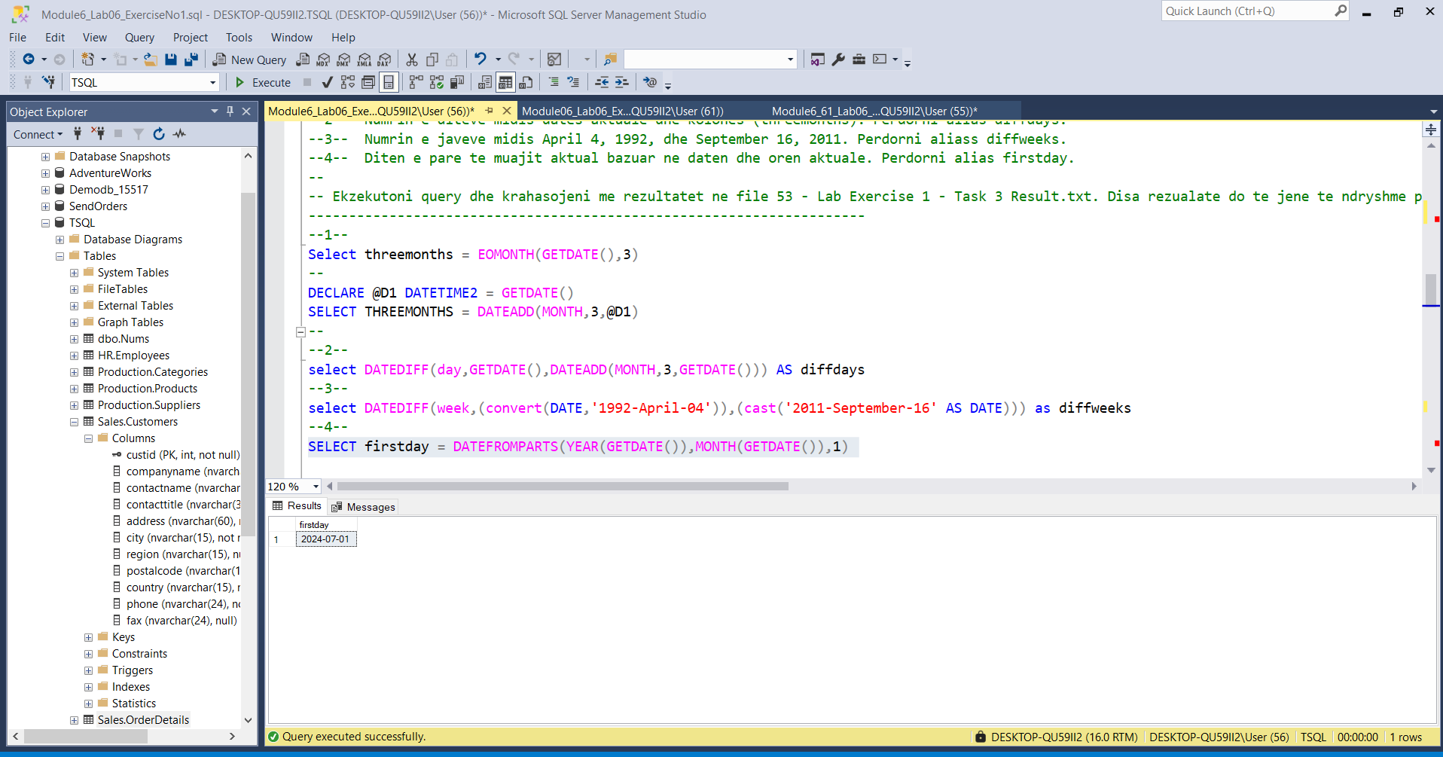

---------------------------------------------------------------------

-- Task 4

-- The IT department has written a T-SQL statement that creates and populates a table named Sales.Somedates.

-- Execute the provided T-SQL statement.

-- Write a SELECT statement against the Sales.Somedates table and retrieve the isitdate column. Add a new column named converteddate with a new date data type value based on the column isitdate. If the column isitdate cannot be converted to a date data type for a specific row, then return a NULL.

-- Execute the written statement and compare the results that you got with the desired results shown in the file 54 - Lab Exercise 1 - Task 4 Result.txt.

-- What is the difference between the SYSDATETIME and CURRENT_TIMESTAMP functions?

-- What is a language-neutral format for the DATE type?

---------------------------------------------------------------------

---------------------------------------------------------------------

-- Detyra 4

--1-- Ekzekutoni query e meposhtme

--2-- Nxjerrni isitdate nga tabela Sales.Somedates, shtoni nje kolone te re te quajtur converteddate me nje tip te ri date bazuar ne kolonen isitdate.

----- Nese kolona isitdate nuk mund te konvertohet ne tipin date per ndonje resht specifik, atehere ktheni vleren NULL.

--3-- Ekzekutoni query dhe krahasojeni me rezultatet ne file 54 - Lab Exercise 1 - Task 4 Result.txt.

--4-- Cila eshte diferenca midis funksioneve SYSDATETIME dhe CURRENT_TIMESTAMP?

--5-- Çfarë është një format neutral gjuhesor për tipin DATE?

---------------------------------------------------------------------

SET NOCOUNT ON;

DROP TABLE IF EXISTS Sales.Somedates;

CREATE TABLE Sales.Somedates (

isitdate varchar(9)

);

INSERT INTO Sales.Somedates (isitdate) VALUES

('20110101'),

('20110102'),

('20110103X'),

('20110104'),

('20110105'),

('20110106'),

('20110107Y'),

('20110108');

SET NOCOUNT OFF;

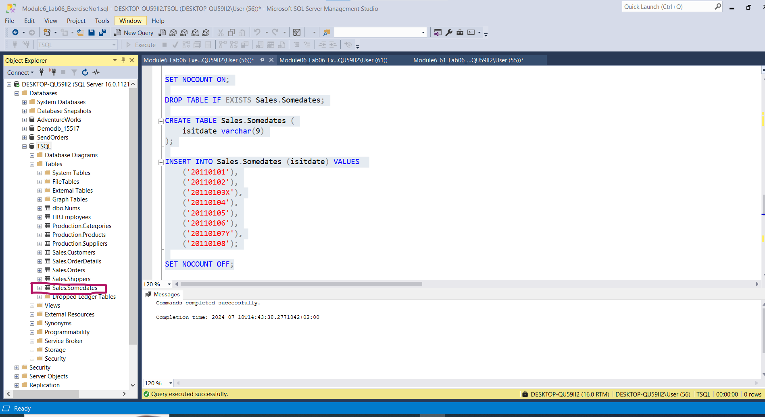

SELECT isitdate

FROM Sales.Somedates;

|Si më poshtë:

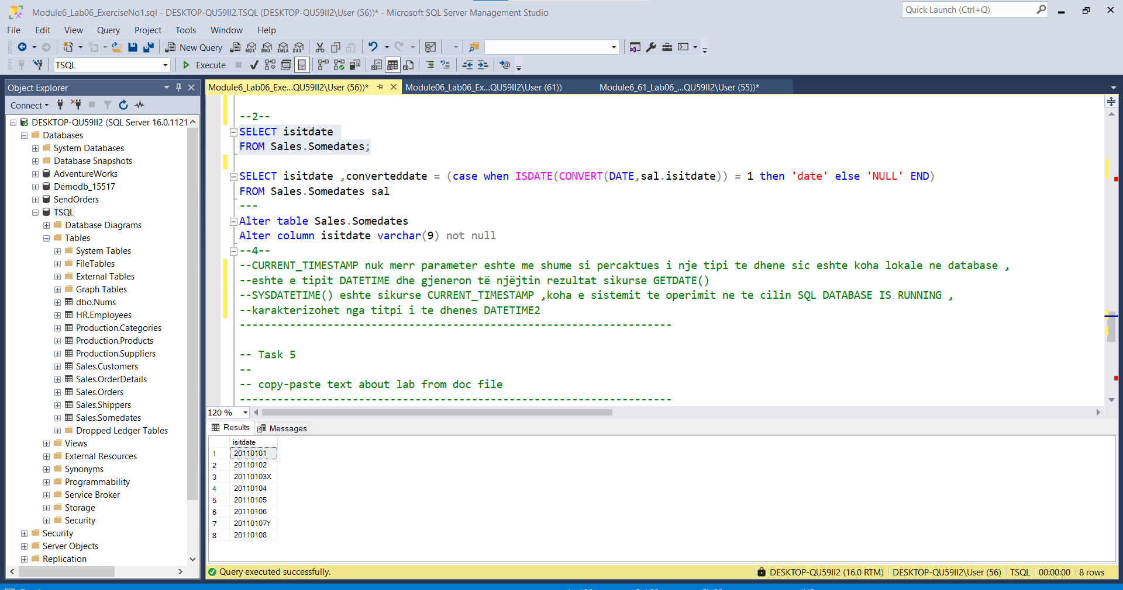

--2--

SELECT isitdate ,converteddate = (case when ISDATE(CONVERT(DATE,sal.isitdate)) = 1 then 'date' else 'NULL' END)

FROM Sales.Somedates sal

---

Alter table Sales.Somedates

Alter column isitdate varchar(9) not null

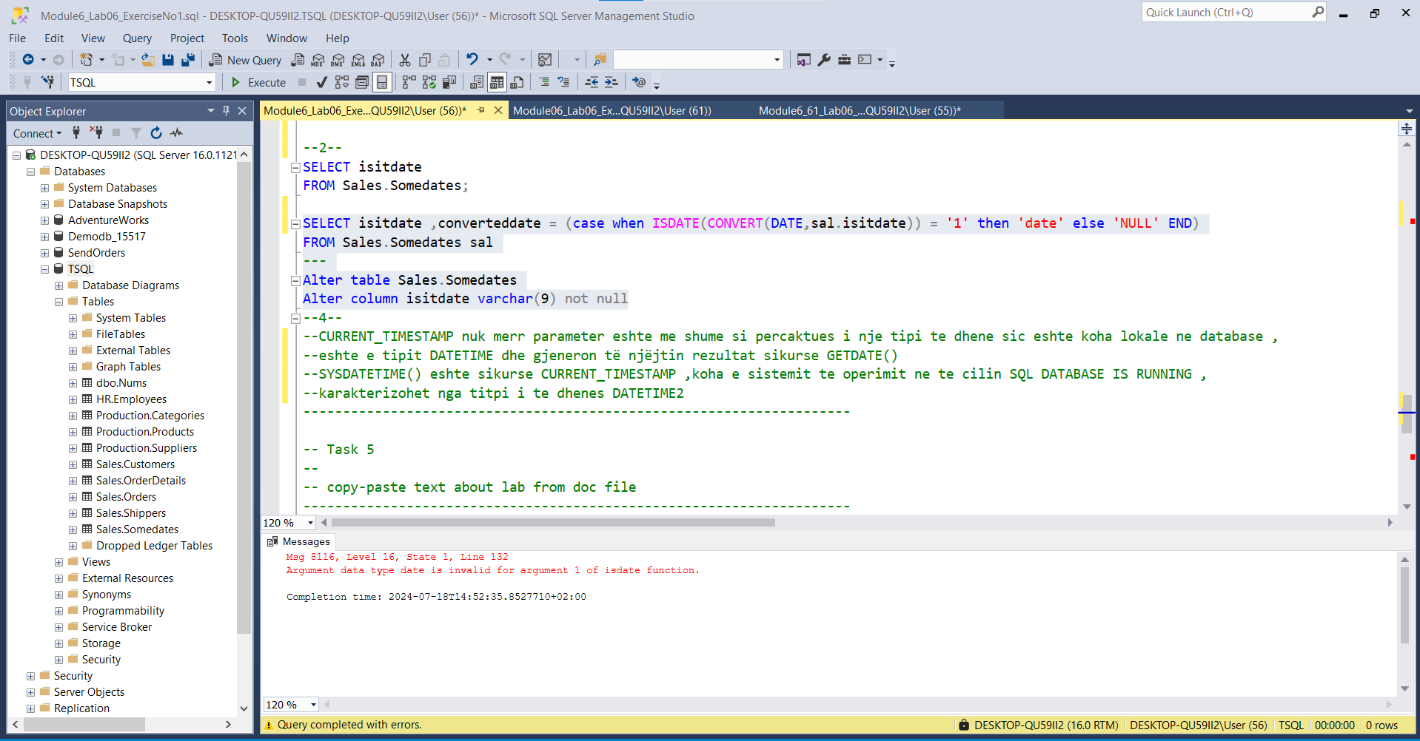

--4--

CURRENT_TIMESTAMP nuk merr parameter eshte me shume si percaktues i nje tipi te dhene sic eshte koha lokale ne database ,

eshte e tipit DATETIME dhe gjeneron të njëjtin rezultat sikurse GETDATE()

SYSDATETIME() eshte sikurse CURRENT_TIMESTAMP ,koha e sistemit te operimit ne te cilin SQL DATABASE IS RUNNING ,

karakterizohet nga titpi i te dhenes DATETIME2

---------------------------------------------------------------------

-- Task 5

--

-- copy-paste text about lab from doc file

---------------------------------------------------------------------

-- drop the table

DROP TABLE Sales.Somedates;

---------------------------------------------------------------------

-- Detyra 5

--

-- Kopjoni tekstin rreth laboratorit nga file doc

---------------------------------------------------------------------

-- Fshini tabelen

DROP TABLE Sales.Somedates;

-- STATEMENT u ekzekutua me sukses!!!

